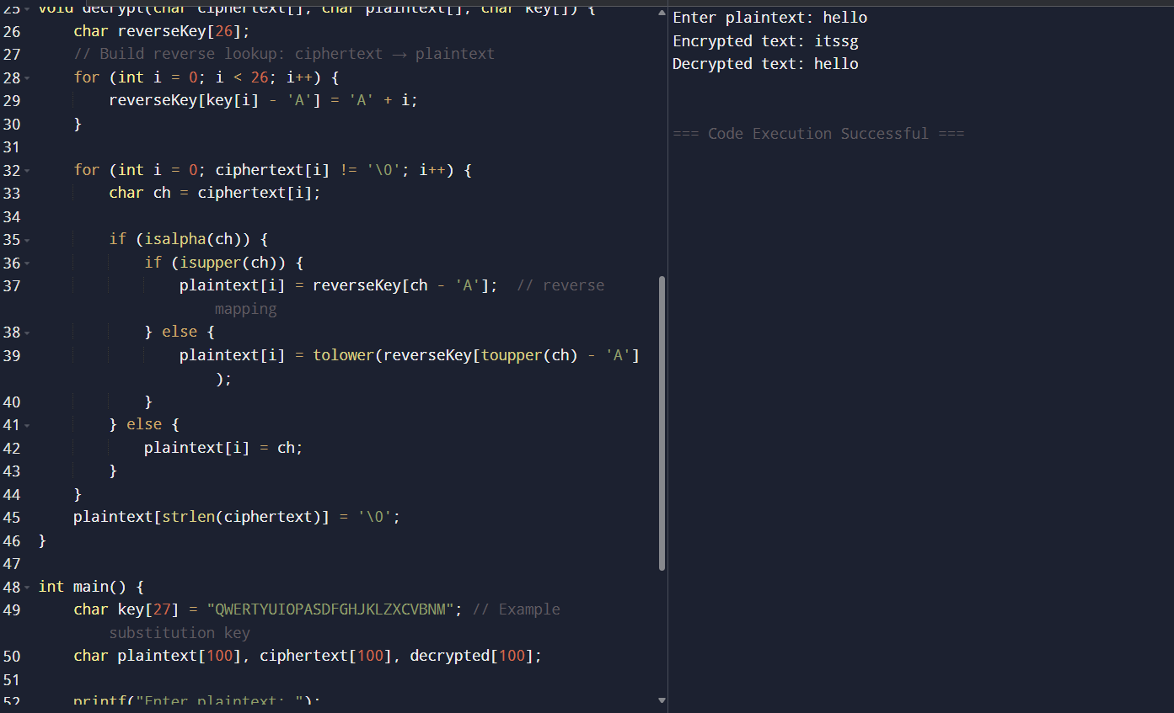2. Write a C program for monoalphabetic substitution cipher maps a plaintext alphabet to a ciphertext alphabet, so that each letter of the plaintext alphabet maps to a single unique letter of the ciphertext alphabet. 